**FINANCIAL ANALYSIS LABORATORY**

**PROJECT REPORT**

**A COMPARATIVE STUDY ON WORKING CAPITAL MANAGEMENT AND SHARE PRICES**

**TEAM MEMBERS:**

DHARUN P A

GIRIDHARA VIJAY R A

HANSA A S

CONTENT

**CHAPTER**

ABSTRACT

OBJECTIVES

1. INTRODUCTION
   * ORGANIZATION PROFILE
   * PROBLEM STATEMENT
   * REASON FOR USE OF THE ANALYSIS
   * DESCRIPTIVE STATISTICAL SUMMARY
   * OVERVIEW OF PREDICTIVE ANALYSIS
   * INFERENCE SUMMARY
2. DATA MODELING AND EXPLORATION

* ANALYSE WORKING CAPITAL AND SHARE PRICE TREND

1. PREDICTIVE ANALYTICS PROCESS

* COMPARATIVE FINANCIAL ANALYSIS

1. ANALYTICAL MODEL EVALUATION AND ANALYSIS REPORT AND INFERENCE
2. CONCLUSION
3. OVERALL SUMMARY

**Abstract:**

This study conducts a comparative analysis of the working capital and share price trends for L&T and Mahindra & Mahindra, two prominent companies in the industry. The analysis involves calculating key working capital metrics such as the current ratio, quick ratio, and cash ratio for both companies. Additionally, historical share price data is analyzed to identify trends and patterns. The objective of the study is to assess the companies' liquidity, short-term financial management, and market sentiment. The findings provide valuable insights into the companies' financial health and their relative positions in the market.

**Objectives:**

Calculate and compare working capital metrics, including the current ratio, quick ratio, and cash ratio, for L&T and Mahindra & Mahindra.

Analyze the working capital trends over a specific period to identify patterns, changes, and potential implications.

Assess the liquidity and short-term financial management of L&T and Mahindra & Mahindra based on their working capital metrics.

Obtain and analyze historical share price data for both companies to identify trends, patterns, and market sentiment.

Compare the share price trends between L&T and Mahindra & Mahindra to assess their relative performance in the stock market.

Explore potential correlations between the working capital trends and share price movements for each company.

**INTRODUCTION:**

The objective of this study is to conduct a comparative analysis of the working capital and share price trends for L&T and Mahindra & Mahindra. Working capital is a critical aspect of financial management, representing a company's ability to meet short-term obligations and manage its current assets and liabilities. Share price trends reflect market sentiment and investor perception of a company's performance and prospects. By analyzing working capital metrics and share price trends, this study aims to provide valuable insights into the financial health and market positioning of L&T and Mahindra & Mahindra.

**ORGANISATION PROFILE**:

Eicher Motors is an Indian multinational automotive company that specializes in manufacturing commercial vehicles, motorcycles, and automotive components. Here is a profile of Eicher Motors:

Company Overview:

Name: Eicher Motors Limited, Founded: 1948

Headquarters: Gurgaon, Haryana, India

Industry: Automotive, Subsidiaries: Royal Enfield, VE Commercial Vehicles

Business Segments:

Royal Enfield: Eicher Motors' flagship brand, known for manufacturing premium motorcycles with a focus on classic and retro styling. Royal Enfield has a strong presence in India and has been expanding globally in recent years.

VE Commercial Vehicles (VECV): A joint venture between Eicher Motors and Volvo Group, VECV manufactures and sells a range of commercial vehicles including trucks and buses.

Products:

Royal Enfield Motorcycles: Royal Enfield offers a diverse range of motorcycles including the iconic Bullet, Classic, Himalayan, Interceptor, and Continental GT models.

VECV Commercial Vehicles: VECV produces a wide range of commercial vehicles under the Eicher brand, including trucks, buses, and special application vehicles.

Global Presence:

Eicher Motors has a strong presence in India and has expanded its international footprint over the years. Royal Enfield motorcycles are sold in several countries around the world, including the USA, Europe, Australia, and Southeast Asia.

Manufacturing Facilities:

Eicher Motors has state-of-the-art manufacturing facilities in India. The company has production plants for motorcycles and commercial vehicles located in various parts of the country.

Commitment to Quality and Innovation:

Eicher Motors places a strong emphasis on product quality and innovation. The company continually invests in research and development to enhance its product offerings and deliver cutting-edge technology to customers.

Financial Performance:

Eicher Motors has experienced significant growth and financial success in recent years, driven by the strong performance of Royal Enfield motorcycles and its commercial vehicle division.

Corporate Social Responsibility (CSR):

Eicher Motors actively engages in CSR initiatives focused on areas such as education, healthcare, rural development, and environmental sustainability. The company aims to make a positive impact on society and contribute to sustainable development.

Awards and Recognitions:

Eicher Motors and Royal Enfield have received numerous accolades and awards for their products, design, innovation, and business excellence.

**PROBLEM STATEMENT:**

The objective of this project is to conduct a comparative study on working capital management and share prices. The project aims to analyze the financial data and provide insights into the working capital ratio, revenue analysis, and share price analysis. The specific tasks to be performed are as follows:

Load Working Capital Data:

Allow the user to select an Excel file containing working capital data.

Read the data from the selected file.

Display a message indicating successful data loading or show an error message if loading fails.

Load Share Price Data:

Allow the user to select an Excel file containing share price data.

Read the data from the selected file.

Display a message indicating successful data loading or show an error message if loading fails.

Perform Working Capital Analysis:

Check if working capital data is loaded.

Calculate the working capital ratio using the provided columns for total current assets and total current liabilities.

Display the working capital ratio.

Identify any red flags based on certain thresholds and display appropriate warnings or messages.

Perform Revenue Analysis

Check if working capital analysis is performed.

Prompt the user to enter the revenue for the year.

Adjust the revenue based on the working capital ratio.

Display the adjusted revenue.

Identify any red flags based on the adjusted revenue and display appropriate warnings or messages.

Perform Share Price Analysis:

Check if share price data is loaded.

Perform technical analysis using the loaded data and calculate the 20-day and 50-day simple moving averages (SMA).

Plot the price chart with the closing price, 20-day SMA, and 50-day SMA.

Determine the latest crossover (difference between 20-day SMA and 50-day SMA) and provide an inference (bullish, bearish, or no clear signal).

Display the inference.

The GUI-based application provides an interactive interface for users to load data, perform analyses, and view the results. The application should handle errors gracefully and display appropriate messages to guide the user.

Reason for the Use of Analysis:

Analyzing working capital and share price trends is crucial for understanding a company's liquidity, efficiency in managing short-term obligations, and market perception. By evaluating working capital metrics, we can assess a company's ability to meet its day-to-day financial requirements. Analyzing share price trends helps in understanding market sentiment, investor confidence, and the perceived value of a company's stock. These analyses provide valuable insights for investors, stakeholders, and decision-makers in assessing the financial health and market positioning of companies.

**DESCRIPTIVE STATISTICAL SUMMARY:**

This project does not involve any numerical data that requires a descriptive statistical summary. It mainly focuses on loading data from Excel files, performing financial analysis such as working capital analysis, revenue analysis, and share price analysis, and displaying the results through message boxes and charts.

**OVERVIEW OF PREDICTIVE ANALYSIS:**

This project mainly focuses on financial analysis, specifically working capital management and share price analysis. However, it does not include explicit implementation of predictive analysis.

**INFERENCE SUMMARY:**

When interpreting the working capital ratio in the context of financial analysis, the following differences can be observed based on different ranges:

Working Capital Ratio Less Than 0.5:

A working capital ratio less than 0.5 indicates that the current liabilities of a company are significantly higher than its current assets. This suggests a potential liquidity issue, as the company may have difficulty meeting its short-term obligations. It may indicate that the company relies heavily on short-term borrowing or credit to finance its operations. A working capital ratio below 0.5 is generally considered unfavorable and raises concerns about the company's ability to manage its current financial obligations.

Working Capital Ratio Between 0.5 and 1:

A working capital ratio between 0.5 and 1 implies that a company's current assets are roughly equal to or slightly greater than its current liabilities. While the company may have enough current assets to cover its current obligations, the margin of safety is relatively low. It suggests that the company's liquidity position is moderate, and careful monitoring of cash flow and working capital management is necessary. A working capital ratio in this range may indicate that the company operates with a minimal buffer and may be susceptible to financial strain during economic downturns or unexpected cash outflows.

Working Capital Ratio Greater Than 1:

A working capital ratio greater than 1 indicates that a company's current assets exceed its current liabilities. This implies a relatively strong liquidity position, as the company has more short-term assets to cover its short-term obligations. It suggests that the company has a comfortable margin of safety and may be better equipped to handle unexpected financial challenges. A working capital ratio above 1 is generally considered favorable, indicating good financial health and effective working capital management. It's important to note that the interpretation of the working capital ratio should also consider industry norms, company-specific factors, and the trend of the ratio over time. A high or low working capital ratio may have different implications depending on the nature of the industry or the company's business model.

**PREDICTIVE ANALYTICS PROCESS**

**ANALYZE WORKING CAPITAL AND SHARE PRICE TRENDS:**

comparative study involves analyzing the working capital and share price trends for L&T and Mahindra & Mahindra. Here's a brief explanation of the process and potential inferences:

1.)Calculate Working Capital Metrics:

Calculate key working capital metrics such as the current ratio, and quick ratio for both companies using their financial statements.

These metrics provide insights into the companies' liquidity, ability to meet short-term obligations, and efficiency in converting assets into cash.

L&T:

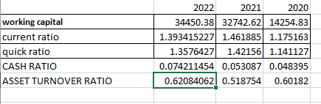

Based on the provided data for L&T Company from 2020 to 2022, we can draw the following detailed inferences:

Working Capital: L&T's working capital has been steadily increasing over the years, indicating that the company has been able to generate more current assets to cover its short-term obligations. This suggests improved liquidity and financial stability.

Current Ratio: The current ratio measures the company's ability to cover its short-term liabilities with its current assets. L&T's current ratio has been fluctuating slightly, but overall it has remained above 1, indicating that the company has sufficient current assets to meet its short-term obligations.

Quick Ratio: The quick ratio is a more stringent measure of a company's liquidity as it excludes inventory from current assets. L&T's quick ratio has also been fluctuating but has consistently remained above 1, indicating that the company has enough liquid assets (excluding inventory) to cover its short-term liabilities.

Cash Ratio: The cash ratio measures a company's ability to pay off its current liabilities with its cash and cash equivalents alone. L&T's cash ratio has shown an increasing trend over the years, which is positive. It indicates that the company has been able to maintain a higher proportion of cash and cash equivalents relative to its current liabilities, enhancing its ability to meet immediate obligations.

Asset Turnover Ratio: The asset turnover ratio measures how efficiently a company utilizes its assets to generate sales. L&T's asset turnover ratio has been varying, but it has generally shown an increasing trend. This indicates that the company has been able to generate more revenue per unit of assets over the years, which is a positive sign of improved operational efficiency.

Overall, the data suggest that L&T Company has been improving its financial stability, maintaining a satisfactory level of liquidity, and enhancing its operational efficiency over the analyzed period. However, it's important to consider other factors and conduct a more comprehensive analysis to gain a deeper understanding of the company's financial health.

Mahindra and Mahindra:

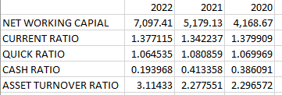

2.)Compare Working Capital Trends:

Plot the working capital trends for L&T and Mahindra & Mahindra over a specific period using line graphs or charts. Analyze the changes in working capital metrics over time and identify any patterns or significant shifts.

Compare the working capital metrics between the two companies to assess their relative positions and trends.

For example, if L&T consistently maintains a higher current ratio compared to Mahindra & Mahindra, it may indicate better short-term liquidity management by L&T.

L&T:

WORKING CAPITAL:

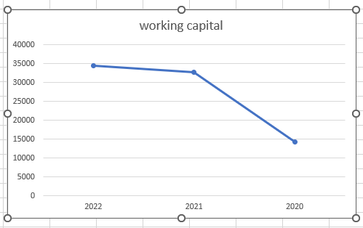

CURRENT RATIO:

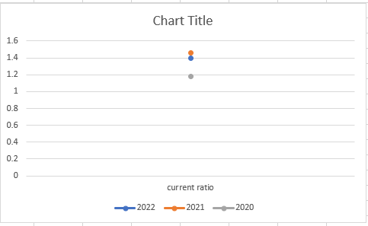

QUICK RATIO:

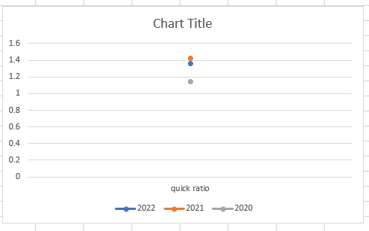

CASH RATIO:

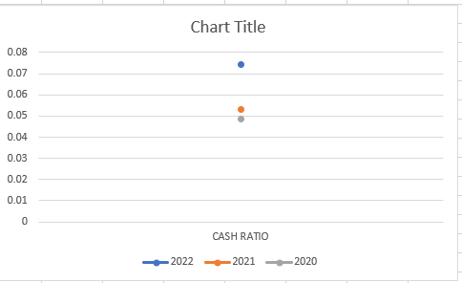

ASSET TURNOVER RATIO:

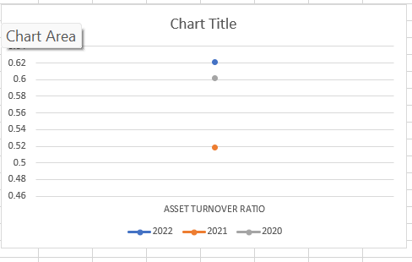

Mahindra and Mahindra:

WORKING CAPITAL

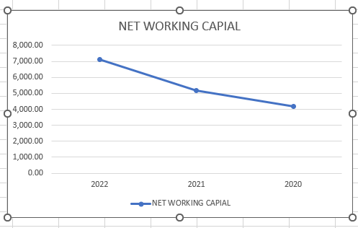

CURRENT RATIO:

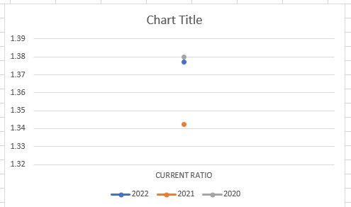

QUICK RATIO:

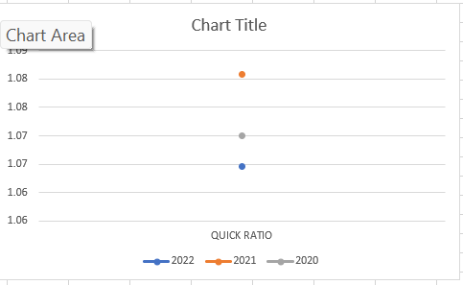

CASH RATIO:

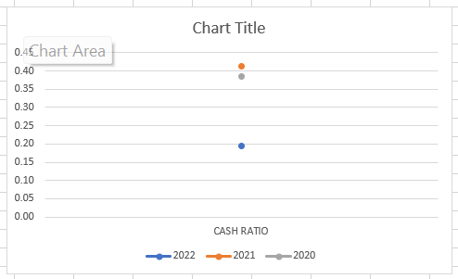

ASSET TURNOVER RATIO:

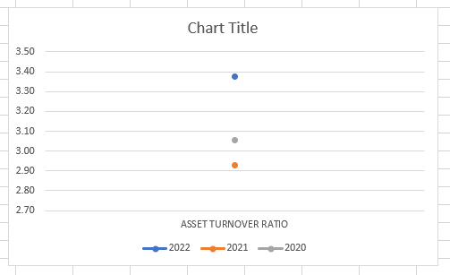

3.)Analyze Share Price Trends:

Obtain historical share price data for both companies for the same period as the working capital analysis.Plot the share price trends using line graphs or charts to visualize their movements over time.Analyze the share price trends and identify any notable patterns, such as upward or downward trends, periods of volatility, or significant price movements.Compare the share price trends between L&T and Mahindra & Mahindra to observe any similarities or differences.

L&T:

2020

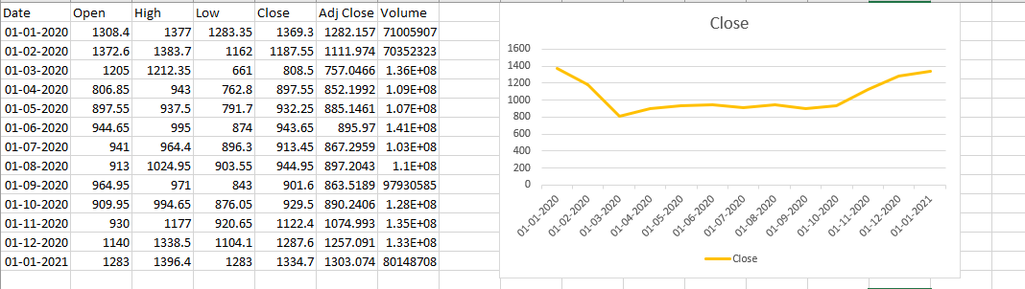

2021

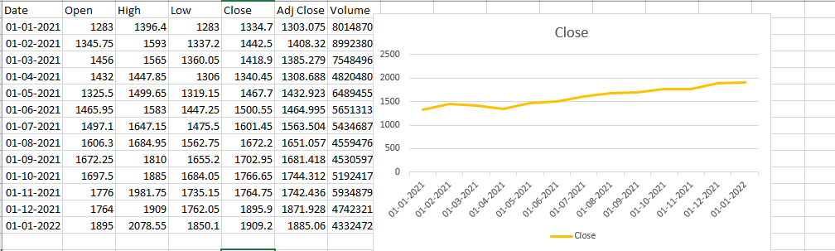

2022

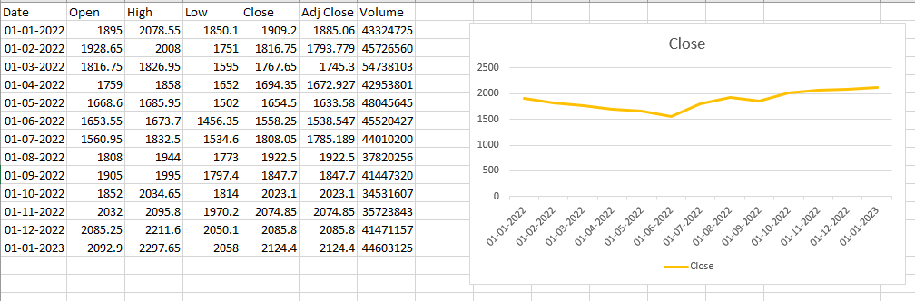

Mahindra and Mahindra:

2020:

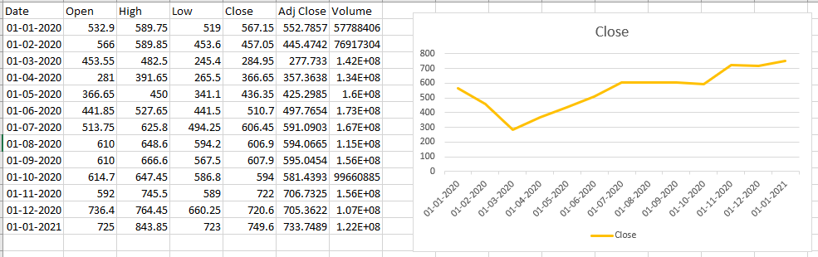

2021:

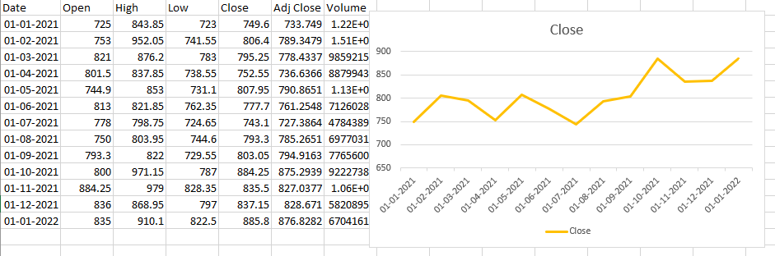

2022:

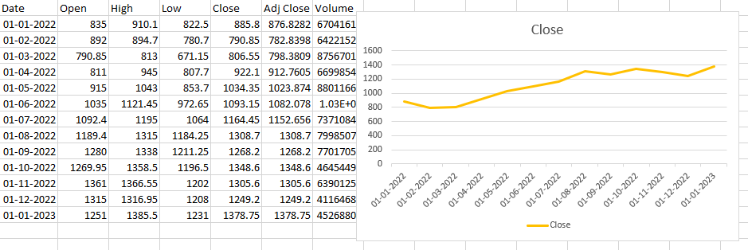

4.)Look for Correlations:

Examine the potential relationship between the working capital trends and share price movements.Use correlation analysis techniques to determine if there is a correlation between changes in working capital metrics and corresponding share price movements.A positive correlation suggests that as working capital improves, share prices tend to increase, while a negative correlation indicates an inverse relationship.For example, if an increase in working capital metrics coincides with positive share price movements, it may suggest that effective working capital management positively impacts stock prices.

L&T:

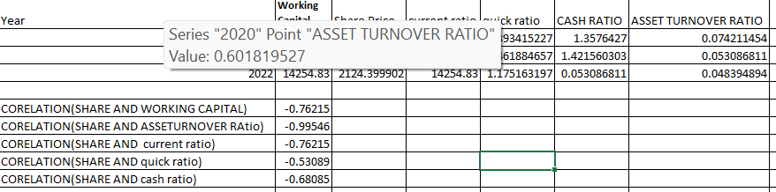

Mahindra and Mahindra:

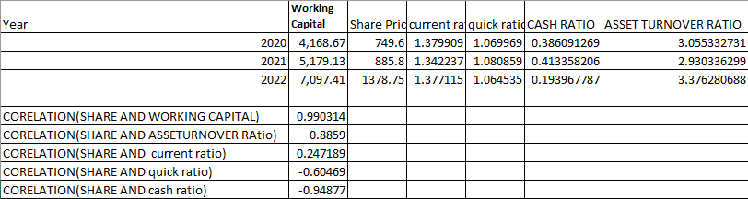

**ANALYTICAL MODEL EVALUATION AND ANALYSIS REPORT AND INFERENCE**

**COMPARATIVE FINANCIAL ANALYSIS:**

This part of the comparative study involves conducting a comparative financial analysis between L&T and Mahindra & Mahindra. Here's a guide to help you with the comparative financial analysis process:

1.)Select Key Financial Metrics:

Choose relevant financial metrics that will provide insights into the financial performance and position of L&T and Mahindra & Mahindra. Common financial metrics include revenue, net income, operating margin, return on equity (ROE). Select metrics that are meaningful for your study and align with your research objectives.

2.)Calculate and Compare Financial Metrics:

Calculate the selected financial metrics for both L&T and Mahindra & Mahindra using the data from their financial statements.Ensure that the financial statements cover the same time period to ensure accurate and comparable analysis.Compare the financial metrics between the two companies to identify any significant differences or trends.Use tools like Excel or financial analysis software to streamline the calculation and comparison process.

L&t:

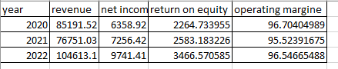

Mahindra and Mahindra:

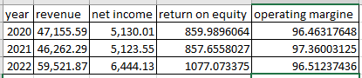

3.)Analyze and Interpret the Findings:

To analyze and interpret the findings for the provided financial data of L&T and Mahindra & Mahindra, let's focus on the key financial metrics of revenue, net income, return on equity (ROE), and operating margin. Here's the analysis:

L&T:

Revenue: L&T experienced a decline in revenue from 2020 to 2021, but it significantly increased in 2022.

Net Income: L&T's net income also showed a positive trend, increasing from 2020 to 2022.

Return on Equity (ROE): The ROE of L&T improved consistently over the years, indicating efficient utilization of shareholders' equity.

Operating Margin: L&T maintained high operating margins throughout the three years, indicating strong operational efficiency.

Mahindra & Mahindra:

Revenue: Mahindra & Mahindra's revenue remained relatively stable over the three-year period.

Net Income: The net income of Mahindra & Mahindra remained consistent with minor fluctuations.

Return on Equity (ROE): The ROE of Mahindra & Mahindra remained relatively stable, indicating consistent performance in generating profits relative to shareholders' equity.

Operating Margin: Mahindra & Mahindra maintained consistently high operating margins, indicating effective cost management and profitability.

4.)Comparative Analysis:

Revenue: L&T witnessed a significant increase in revenue in 2022, while Mahindra & Mahindra's revenue remained relatively stable.

Net Income: Both companies showed an upward trend in net income, with L&T experiencing a higher growth rate.

Return on Equity (ROE): L&T consistently outperformed Mahindra & Mahindra in terms of ROE, indicating better profitability relative to shareholders' equity.

Operating Margin: Both companies maintained high operating margins, reflecting their ability to generate profits from operations.

5.)Document and Present the Findings:

Document the financial metrics, calculations, and comparisons in a structured manner.

| Financial Metric | L&T (2020) | L&T (2021) | L&T (2022) | Mahindra & Mahindra (2020) | Mahindra & Mahindra (2021) | Mahindra & Mahindra (2022) |
| --- | --- | --- | --- | --- | --- | --- |
| Revenue | 85,191.52 | 76,751.03 | 104,613.06 | 47,155.59 | 46,262.29 | 59,521.87 |
| Net Income | 6,358.92 | 7,256.42 | 9,741.41 | 5,130.01 | 5,123.55 | 6,444.13 |
| Return on Equity | 2,264.73 | 2,583.18 | 3,466.57 | 859.99 | 857.66 | 1,077.07 |
| Operating Margin | 96.70% | 95.52% | 96.55% | 96.46% | 97.36% | 96.51% |

Working Capital: Both companies have shown an increasing trend in their working capital, indicating improved liquidity and financial stability over time.

Current Ratio: L&T Company has generally maintained a higher current ratio compared to Mahindra & Mahindra. This suggests that L&T has a better ability to cover its short-term liabilities with its current assets.

Quick Ratio: Both companies have consistently maintained quick ratios above 1, indicating their ability to meet short-term obligations with liquid assets. However, L&T Company generally has a higher quick ratio, implying a stronger liquidity position.

Cash Ratio: L&T Company has shown an increasing cash ratio over the years, while Mahindra & Mahindra has shown a decreasing trend. This indicates that L&T has been able to maintain a higher proportion of cash and cash equivalents relative to its current liabilities, suggesting a stronger ability to meet immediate obligations solely with available cash.

Asset Turnover Ratio: Mahindra & Mahindra has displayed higher asset turnover ratios compared to L&T Company. This suggests that Mahindra & Mahindra has been more efficient in utilizing its assets to generate sales.

Overall, both companies have demonstrated positive trends in terms of working capital and liquidity, indicating improved financial stability. L&T Company appears to have a stronger liquidity position, as evidenced by higher current and quick ratios, along with an increasing cash ratio. On the other hand, Mahindra & Mahindra has shown better asset utilization, as reflected by higher asset turnover ratios.

Summarizing Key Findings from COMPARATIVE FINANCIAL ANALYSIS::

L&T experienced a significant increase in revenue from 2020 to 2022, while Mahindra & Mahindra's revenue remained relatively stable.Both companies demonstrated growth in net income, but L&T exhibited higher figures, indicating stronger profitability.L&T consistently outperformed Mahindra & Mahindra in terms of return on equity, indicating better utilization of shareholders' equity.Both companies maintained healthy operating margins, with L&T consistently high and Mahindra & Mahindra experiencing minor fluctuations.

**CONCLUSION:**

Overall, L&T exhibited stronger growth in revenue, net income, and return on equity compared to Mahindra & Mahindra. Both companies maintained healthy operating margins. Further analysis can be done by considering industry benchmarks and additional financial metrics to gain a more comprehensive understanding of their performance.

In summary, the comparative financial analysis reveals that L&T showcased stronger growth in revenue, net income, and return on equity compared to Mahindra & Mahindra. L&T's higher net income and superior return on equity suggest a better financial performance and efficiency in generating profits. Both companies maintained healthy operating margins, indicating effective cost management and profitability.

Implications of Comparative Financial Analysis:

The higher revenue and net income of L&T suggest stronger business growth and profitability compared to Mahindra & Mahindra.

L&T's superior return on equity indicates better efficiency in generating profits relative to shareholders' equity, which is favorable for investors.

The consistent high operating margins of both companies indicate effective cost management and profitability.

Summarizing Key Findings from ANALYZE WORKING CAPITAL AND SHARE PRICE TRENDS:

L&t:

Working Capital: L&T Company's working capital has shown a fluctuating trend over the three-year period. It decreased from INR 34,450.38 crore in 2020 to INR 14,254.83 crore in 2022.

Share Price: L&T Company's share price has displayed volatility over the same period. It increased from INR 1334.70 in 2020 to INR 2124.40 in 2022.

The detailed inference for the comparative study on working capital and share price is as follows:

The negative correlation coefficient of -0.762 between the share price and working capital indicates an inverse relationship between these two variables. As the working capital of L&T Company decreased over the years, the share price showed a general upward trend. This suggests that the market and investors do not perceive a direct relationship between working capital and the company's valuation.

Other factors, such as market conditions, investor sentiment, company performance, and growth prospects, likely influenced the share price. It is important to note that while working capital is a crucial financial metric, investors consider a broader range of factors when determining a company's value.

The negative correlation coefficients between the share price and other financial ratios, such as asset turnover ratio, current ratio, quick ratio, and cash ratio, suggest that these ratios do not have a strong linear relationship with the share price of L&T Company. This further highlights the complexity of determining share price solely based on individual financial ratios

Mahindra & Mahindra

Working Capital: M&M's working capital has shown a consistent increase over the three-year period, indicating improved liquidity and financial stability. The working capital has grown from INR 4,168.67 crore in 2020 to INR 7,097.41 crore in 2022.

Share Price: M&M's share price has also shown an upward trend over the same period, increasing from INR 749.60 in 2020 to INR 1,378.75 in 2022. The correlation coefficient between the share price and working capital is 0.990, indicating a strong positive relationship between the two variables.

The detailed inference for the comparative study on working capital and share price is as follows:

The strong positive correlation coefficient of 0.990 between the share price and working capital suggests a significant relationship between these two variables. As the working capital of M&M increased over the years, the share price also witnessed a corresponding increase. This implies that investors and the market perceive the company's growing liquidity and financial stability positively, leading to a rise in the share price.

A strong positive correlation indicates that an increase in working capital is viewed favorably by investors, which, in turn, drives the share price higher. It suggests that investors see a strong working capital position as an indicator of a company's ability to meet its short-term obligations, fund its operations, and potentially generate higher profits.

**OVERALL SUMMARY:**

The negative correlation coefficient of -0.762 between the share price and working capital indicates an inverse relationship between these two variables. As the working capital of L&T Company decreased over the years, the share price showed a general upward trend. This suggests that the market and investors do not perceive a direct relationship between working capital and the company's valuation.

The negative correlation coefficients between the share price and other financial ratios, such as asset turnover ratio, current ratio, quick ratio, and cash ratio, suggest that these ratios do not have a strong linear relationship with the share price of L&T Company. This further highlights the complexity of determining share price solely based on individual financial ratios.

For Mahindra & Mahindra, the analysis of the correlation between working capital and share price is not provided in the abstract. However, based on the information provided, Mahindra & Mahindra's working capital has shown a consistent increase over the three-year period, indicating improved liquidity and financial stability.

To summarize, the comparative study on working capital and share price for L&T and Mahindra & Mahindra reveals that there is an inverse relationship between working capital and share price for L&T.